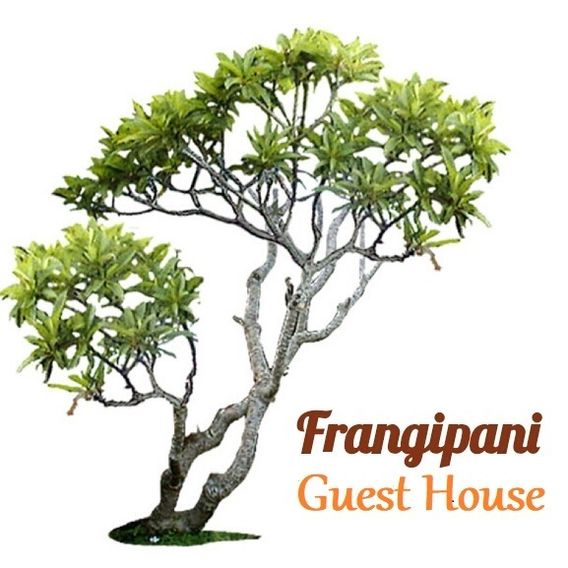

Frangipani Transport and

Tours

- We offer complimentary transfers from the airport or ferry when you arrive, and include a short village tour and check in. You should arrange your own taxi on leaving, or if necessary we can pick you up at a cost of $30 usd per person.

- A car can be hired at around $60 usd per day if you book in advance and we strongly recommend you do this. They will meet you at the ferry or airport and you can usually leave it there (with the keys in the glove box) at the end, making it much easier to check out.

- A taxi can be called to bring you to the village or transport you to the nearest beach – either River, or Two Foot Bay – from the list on the Frangipani phone.

Our most popular tours are -

Barbuda History Tour - a two hour tour including Martello Tower (River) Coco Point, K Club and Princess Diana beach. $50 USD per person, with drinks, snacks and time to swim.

Barbuda Natural History Tour - a two hour tour including the Caves at Two Foot Bay, $50 USD per person, with drinks and snacks and time to swim.

Darby Cave Walking Tour – a three hour tour to Willy Bob (Codrington House) including a forty minute trek each way to the Darby Cave sink hole, with a chance to track deer or land-turtle, $70 USD per person, with drinks and snacks.

Lagoon Boat Tour – 10am – 1pm or 1pm to 4pm – we pick you up from Frangipani and take you to the boat, where you travel with our friend and local fisherman guide through the lagoon to the Frigate Bird Sanctuary. Then he takes you past Barbuda Belle hotel, along the pink sand beach, ending with a swim at Low Bay and then back to the wharf where we meet you and take you home. $100 USD per person (with the option of stopping for a pre-booked lunch or cocktails at the hotel) or $150 USD pp with a picnic - lobster lunch and beers.

We also do -

Cocktail & Canape Cool Box – for moonrise at Frangipani (watching the sun set and the moon rise at the same time) or any other happy hour event! $50 USD per person, including two ice-cold cocktails and two canapes of your choice - delivered to you.

DIY Grill – We bring you lobster or freshly caught fish, that you can grill yourself; with a selection of delicious prepared salads and sides, for $50 USD per person.

Frangipani Grill Night- we bring a big fish or lobsters (or both) and cook them for you on the grill. Prices from $75 USD per person depending on numbers. We usually serve it with a selection of salads, johnny cakes and rum punch.

